Project #1

Introduction to Aerodynamics and Python

Chung Yin Leung

**Problem 1**

**Approach**

The thickness distribution equation and the camber line function for a NACA airfoil are given. The geometry for a symmetric NACA 0012 airfoil and for a cambered NACA 2412 airfoil needs to be plotted. The camber line must also be plotted as a dashed line.

The equations are defined as functions in Python. One thousand x-values are generated between zero and one. These values are inputted into the functions to generate thickness and camber distance values. Upper surface location values are the summation of the camber values and the thickness values. Lower surface location values are the difference of the camber values and the thickness values. For a symmetric airfoil such as NACA 0012, the camber values are zero. The upper and lower surface location values are plotted against the x-values to generate the profile of each airfoil. The Python *matplotlib.pyplot* package is used to plot the values.

**Equations**

$z_{t}\left(x\right)=\frac{t}{0.2}c\left[0.2969\sqrt{\frac{x}{c}}-0.1260\left(\frac{x}{c}\right)-0.3516{\left(\frac{x}{c}\right)}^{2}+0.2843{\left(\frac{x}{c}\right)}^{3}-0.1015{\left(\frac{x}{c}\right)}^{4}\right]$ (1)

Eq. 1 is the thickness distribution equation for a NACA airfoil, where *t* is the maximum thickness to chord ratio, *c* is the length of the chord line, and *x* is the x-axis position along the airfoil. For a NACA XX12 airfoil, *t* is 0.12.

$z_{c}(x)=\left\{\begin{aligned}m\frac{x}{p^{2}}\left(2p-\frac{x}{c}\right), 0≤x≤pc \\ m\frac{c-x}{{\left(1-p\right)}^{2}}\left(1+\frac{x}{c}-2p\right), pc≤x≤c\end{aligned}\right.$ (2)

Eq. 2 is the camber line equation for a NACA airfoil where m is the maximum camber to chord length, p is the chord-wise location of the maximum camber non-dimensionalized by chord length. For a NACA 24XX airfoil, *m* is 0.02 and *p* is 0.4.

$z_{u/l}(x)=z_{c}(x)±z_{t}(x)\cos\left(\tan^{-1}{\frac{dz_{c}}{dx}}\right)$ (3)

Eq. 3 is the *z* position equation for the upper or lower surface of the airfoil. For the upper surface, *zt* is added to *zc*. For the lower surface, *zt* is subtracted from *zc*. Calculations using equation 3 ignore the effect of the cosine term on *zt*.

**Results**

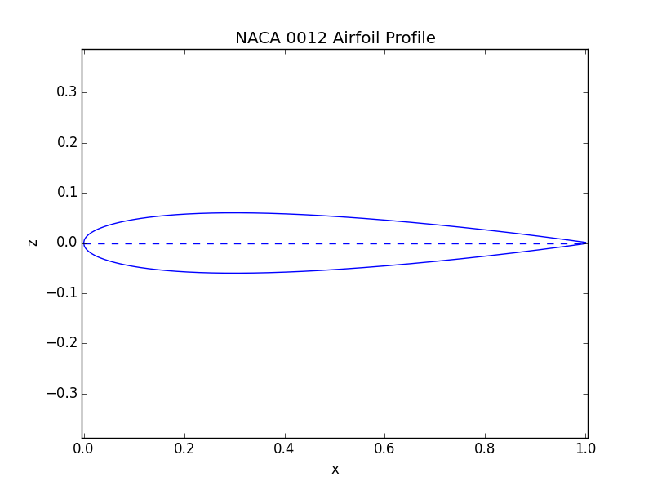

**Figure 1: Plot of NACA 0012 Airfoil Profile**

Figure 1 contains the NACA 0012 airfoil profile generated by the code. The solid blue line is the surface profile of the airfoil while the dashed line is the camber line of the airfoil. As can be seen, the NACA 0012 airfoil is symmetric about the chord line with zero camber.

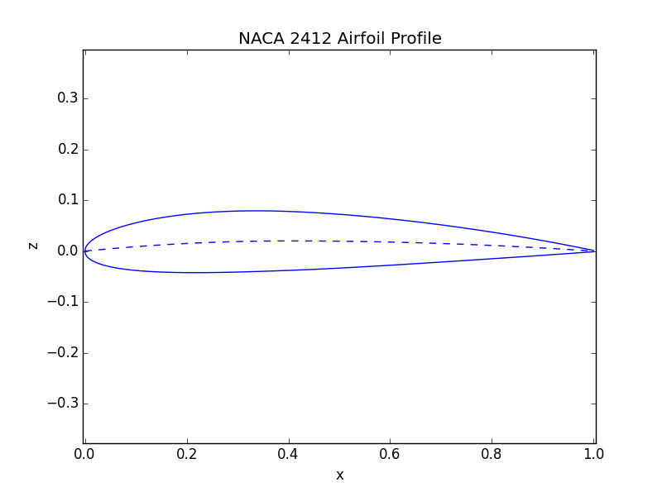

**Figure 2: Plot of NACA 2412 Airfoil Profile**

Figure 2 contains the NACA 2412 airfoil profile generated by the code. The surface profile line is the bold blue line while the camber line is the dashed blue line. Compared to Figure 1, the camber causes a small bump around x equals to 0.4. The slope of the camber line is negligible because the cosine term only changes *zt* by a maximum of 0.5%.

**Conclusion**

A camber changes the airfoil by curving both the upper and lower surface profile line. The slope of the camber can be negligible in calculating the surface profile line for small maximum cambers. Lastly, NACA airfoils are defined by two equations and three constants obtained from the NACA numbering notation.

**Problem 2**

**Approach**

Pressure field data for a NACA 0012 airfoil at an angle of attack of 8 degrees are used to plot the pressure field. Using Python, the data is read and plotted using the *matplotlib.pyplot*’s *contour()* function.

Surface pressure data are also given for a NACA 0012 airfoil at angles of attack of 0 degrees and 8 degrees and a NACA 2412 airfoil at angles of attack of 0 degrees and 8 degrees. These data are used to plot the negative surface pressure coefficient against non-dimensionalized location along the chord. The lift, drag, and moment coefficients and center of pressure location are then calculated from the data.

The data are read such that upper and lower surface pressure data are separated into their own variables. The sets of upper and lower negative surface pressure coefficients are plotted using *matplotlib.pyplot*’s plotting functions. Functions are defined in Python to evaluate the equations for each coefficient and the center of pressure location. The coefficient equations require an integral; these integrals are evaluated using the trapezoidal rule. Due to differences between upper and lower surface x-position data, the integrals are separated into upper and lower surface terms.

**Equations**

$c_{n}=\int_{0}^{1}{\left(C_{p,l}\right) d\frac{x}{c}}+ \int_{0}^{1}{\left(-C_{p,u}\right) d\frac{x}{c}}$ (4)

Eq. 4 defines the normal force coefficient equation where *Cp,l* and *Cp,u* are the lower and upper surface pressure coefficient, respectively.

$c_{a}=\int_{0}^{1}{\left(C_{p,u}\frac{dz_{u}}{dx}\right) d\frac{x}{c}+ \int_{0}^{1}{\left(-C_{p,l}\frac{dz_{l}}{dx}\right) d\frac{x}{c}}}$ (5)

Eq. 5 defines the axial force coefficient equation where *dzu/dx* and *dzl/dx* are the derivatives of the *zu/l* function for the airfoil.

$c_{m_{LE}}=\frac{1}{c}\left[\int_{0}^{1}{\left(C_{p,u}x+C_{p,u}\frac{dz_{u}}{dx}z_{u}\right) d\frac{x}{c}}+\int_{0}^{1}{\left(-C_{p,l}x-C_{p,l}\frac{dz_{l}}{dx}z_{l}\right) d\frac{x}{c}}\right]$ (6)

Eq. 6 defines the moment coefficient about the leading edge. In Eqns. 4 to 6 the friction coefficient is assumed to be zero.

$c_{l}=c_{n}\cos{α}-c_{a}\sin{α}$ (7)

$c_{d}=c_{n}\sin{α}+c_{a}\cos{α}$ (8)

Eqns. 7 and 8 define the lift and drag coefficients, respectively. Both equations depend on the normal force coefficient, axial force coefficient, and *α*, the angle of attack.

$x_{cp}=-\frac{M}{N}=-\frac{c_{m}}{c_{n}}c$ (9)

Eq. 9 defines the location of center of pressure. It can be simplified to a ratio of the moment and normal force coefficients multiplied by *c*, the chord length.

$\frac{dz_{t}}{dx}=\frac{t}{0.2}\left(\frac{1}{2}0.2969\sqrt{\frac{x}{c}}-0.1260-2(0.3516)\frac{x}{c} + 3\left(0.2843\right){\left(\frac{x}{c}\right)}^{2}- 4\left(0.1015\right){\left(\frac{x}{c}\right)}^{3}\right)$ (10)

Eq. 10 defines the derivative of the thickness distribution function. This is used to calculate the airfoil profile derivative.

$\frac{dz_{c}}{dx}=\left\{\begin{aligned}\frac{2m}{p^{2}}\left(p –\frac{x}{c}\right), 0≤\frac{x}{c}≤p \\ \frac{2m}{{\left(1-p\right)}^{2}}\left(p –\frac{x}{c}\right), p≤\frac{x}{c}≤1\end{aligned}\right.$ (11)

Eq. 11 defines the derivative of the camber function. This is used to calculate the airfoil profile derivative.

$\frac{dz_{u/l}}{dx}=\frac{dz_{c}}{dx}±\frac{dz_{t}}{dx}$ (12)

Eq. 12 defines the derivative of the airfoil profile function which is a combination of the thickness function and camber function. This is used to calculate the axial force coefficient and the moment coefficient.

**Results**

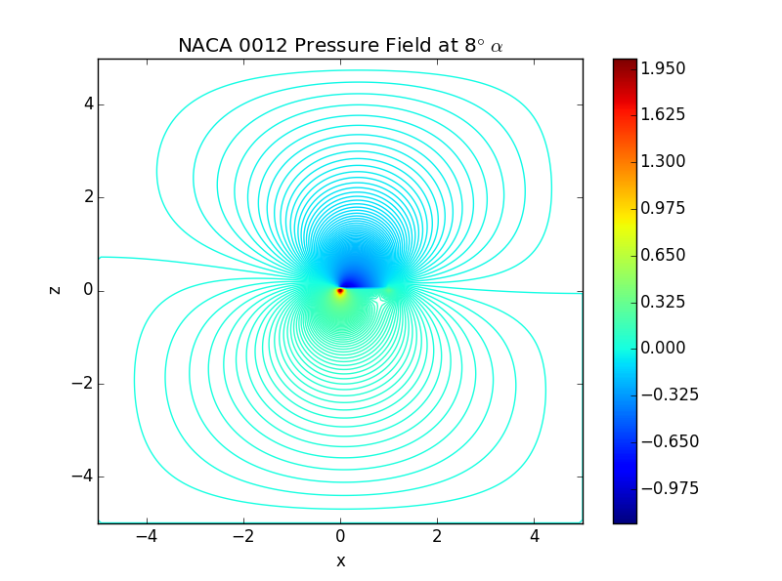

**Figure 3: Contour Plot of NACA 0012 Pressure Field At 8°**

Figure 3 shows the contour plot of the NACA 0012 airfoil at an angle of attack of 8 degrees. The highest pressure and lowest pressure is near the leading edge on the lower and upper surfaces of the airfoil, respectively. However, the low pressures are distributed evenly on the upper surface of the airfoil. Because of that, the lift generated would cause a clockwise moment on the airfoil.

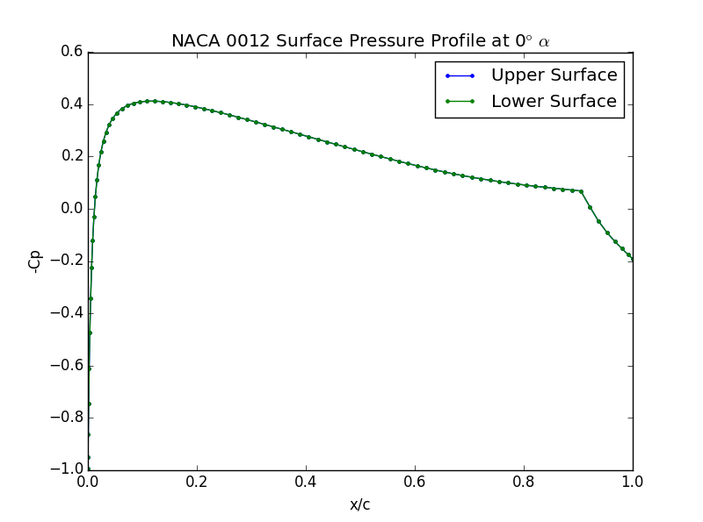

**Figure 4: NACA 0012 Surface Pressure Profile At 0°**

Figure 4 shows the surface pressure profile of the NACA 0012 airfoil at 0 degrees angle of attack. At this angle, the upper and lower surfaces have the same pressure distribution. As a result, the normal force, lift force, and moment about the leading edge are zero, and a center of pressure does not exist.

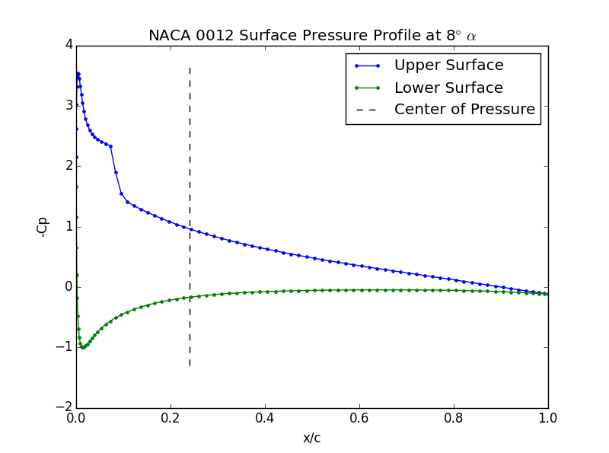

**Figure 5: NACA 0012 Surface Pressure Profile At 8°**

Figure 5 shows the surface pressure profile of the NACA 0012 airfoil at 8 degrees angle of attack. At 8 degrees, the NACA 0012 airfoil generates lift because the negative surface pressure for the upper surface is greater than the negative surface pressure of the lower surface. As such, the center of pressure exists.

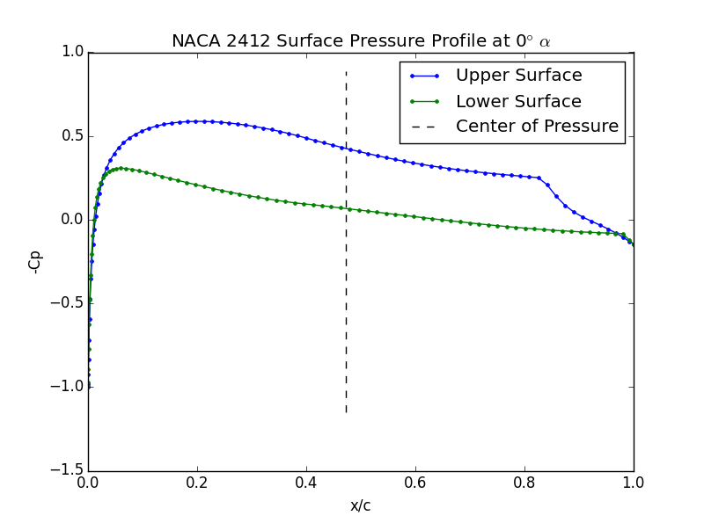

**Figure 6: NACA 2412 Surface Pressure Profile At 0°**

Figure 5 shows the surface pressure profile of the NACA 2412 at 0 degrees angle of attack. With a camber, the airfoil generates lift at 0 degrees angle of attack in comparison to the NACA 0012 at 0 degrees.

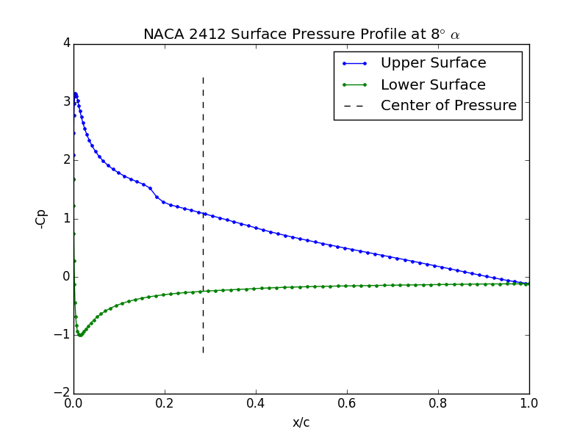

**Figure 7: NACA 2412 Surface Pressure Profile At 8°**

Figure 7 shows the surface pressure profile of the NACA 2412 airfoil at 8 degrees angle of attack. In comparison to the NACA 0012 airfoil at 8 degrees angle of attack, the NACA 2412 airfoil seems to generate a bit more lift by smoothing out the upper surface pressure at x around 0.1.

Generally, from the plots, a camber allows a symmetric airfoil to generate lift at 0 degrees angle of attack. But increasing the angle attack causes pressure difference between the upper and lower surface to increase near the leading edge such that the lift force is unbalanced and create a clockwise moment on the airfoil.

**Table 1: Aerodynamic Data for NACA 0012 and NACA 2412 Airfoils at 0° and 8°**

|  |  |  |  |  |
| --- | --- | --- | --- | --- |
| **Airfoil, Angle of Attack (α)** | **Lift Coeff. (cl)** | **Drag Coeff. (cd)** | **Moment Coeff. (cm)** | **Center of Pressure Position (xcp/c)** |
| NACA 0012, 0° | 0.0000 | 0.004128 | 0.0000 | NaN |
| NACA 0012, 8° | 0.8494 | 0.007775 | -0.2029 | 0.2409 |
| NACA 2412, 0° | 0.2810 | 0.002350 | -0.1330 | 0.4733 |
| NACA 2412, 8° | 1.047 | 0.007096 | -0.2937 | 0.2837 |

Table 1 contains the lift, drag, and moment coefficients and center of pressure position for each case. From the table and agreeing with the plots, adding camber and increasing angle of attack increases the amount of lift and drag generated. Interestingly, adding camber also decreases the amount of drag at the same angle of attack. Lastly, the moment coefficient is proportional to the lift coefficient such that a higher lift coefficient results in a lower moment coefficient.

**Conclusion**

Angle of attack and camber affects the amount of lift and drag generated. Increasing the angle of attack generally causes a higher pressure difference near the leading edge which may generate a pitching moment about the center of the airfoil. At zero degrees angle of attack, a camber is needed to generate lift. In addition, the camber also increases the amount of lift generated and decreases the amount of drag generated at the same angle of attack. Overall, using a cambered airfoil gives a better operational range for an airplane.